**ABHIVYAKTI**

**SYNOPSIS**

Abhivyakti is a website, which provides self-publishing and reading platform to the writers and the readers. Its features and functionality are provided in 3 languages: Gujarati, Hindi and English. It allows users to publish and read original works such as stories, poetries, articles, essays, etc… It also allows readers to rate and to comment content posted by the others.

Through the Gmail Account multiple users can communicate with this website and they can share their ideas, greetings, suggestions with this website and the other users on this platform. This website provides good interface and connectivity to users. It is user friendly website and more convenient for the users.

**PREAMBLE**

**Project Description:**

In this project, I have used PHP, HTML, CSS, JQUERY, AJAX and JAVA Script for creating attractive, more efficient, and extra ordinary website, and also I have used MySQL to create and manage the database. For creating logo and images, I have used Photoshop.

This project is designed with the goal of making the existing site more informative, reliable and secure for that users have to login in this site with valid Gmail ID and Password, then and then users are able to use this site for the various purposes such as creating profile, publishing contents, reading contents, participating in various competitions, etc…

I do my best to protect user’s privacy details and I make sure that I will not share any personally identifiable information with any third party. And the data transactions on the website are also secured.

In short, this is a great opportunity for transcript and a great platform for all people, from the perspective of writing to the world of reading-writing.

**Modules And Description:**

There are mainly 6 modules which are included in this project: Home, Write, Search, Categories, Update and Profile.

1. **Home:**

It is a front layout of the website, which is connected with all the pages of different modules.

1. **Write:**

Writer can publish any content with the help of this module by following easy steps.

1. **Search:**

To find any content or author’s or poet’s name, this module is used.

1. **Categories:**

This module provides many classifications of the different contents: Suspense and Thriller, Romantic, Horror, Funny, Spiritual, Social, etc… Stories, Science Fiction, Child Literature, Woman Special, Article, Poems, Film and Music, Biography, Travel and Tourism, Essay, and Other Stories, etc… Due to these classifications, readers can easily get any require content.

1. **Update:**

This module is used to display notifications and messages.

1. **Profile:**

This module is created to set personal information, maintain library, to keep the record of followers and following, to know the total reviews and rating.

**DIAGRAMS**

**Use Case Diagram:**

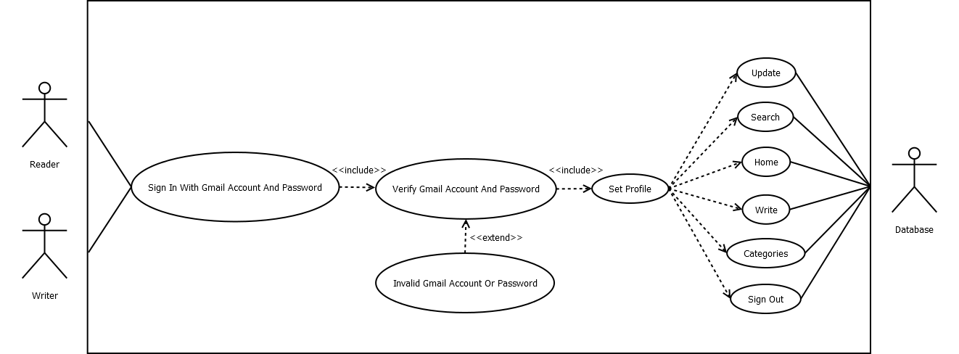

**Sequence Diagram:**

**Set The Profile:**

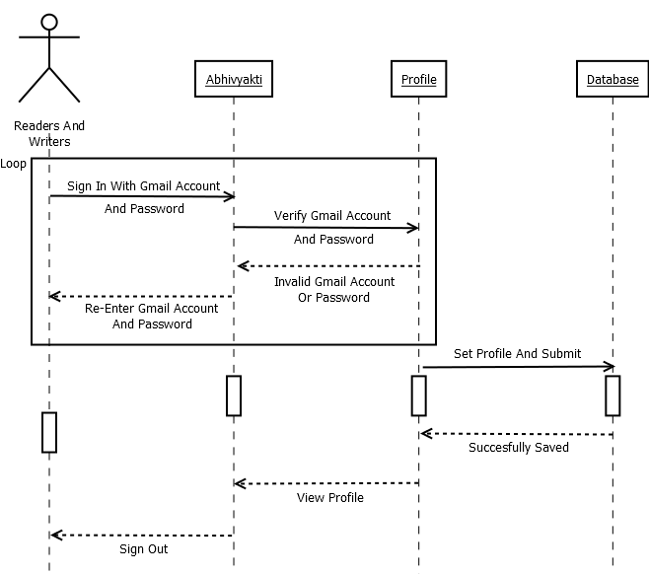

**Write Or Publish The Content:**

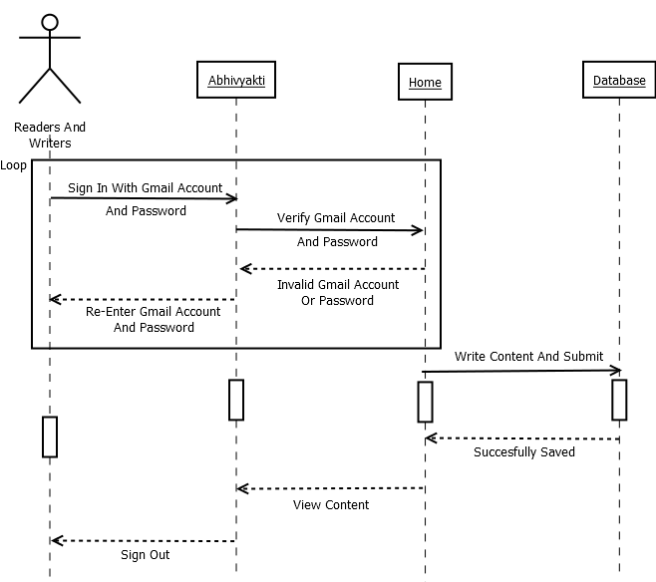

**Class Diagram:**

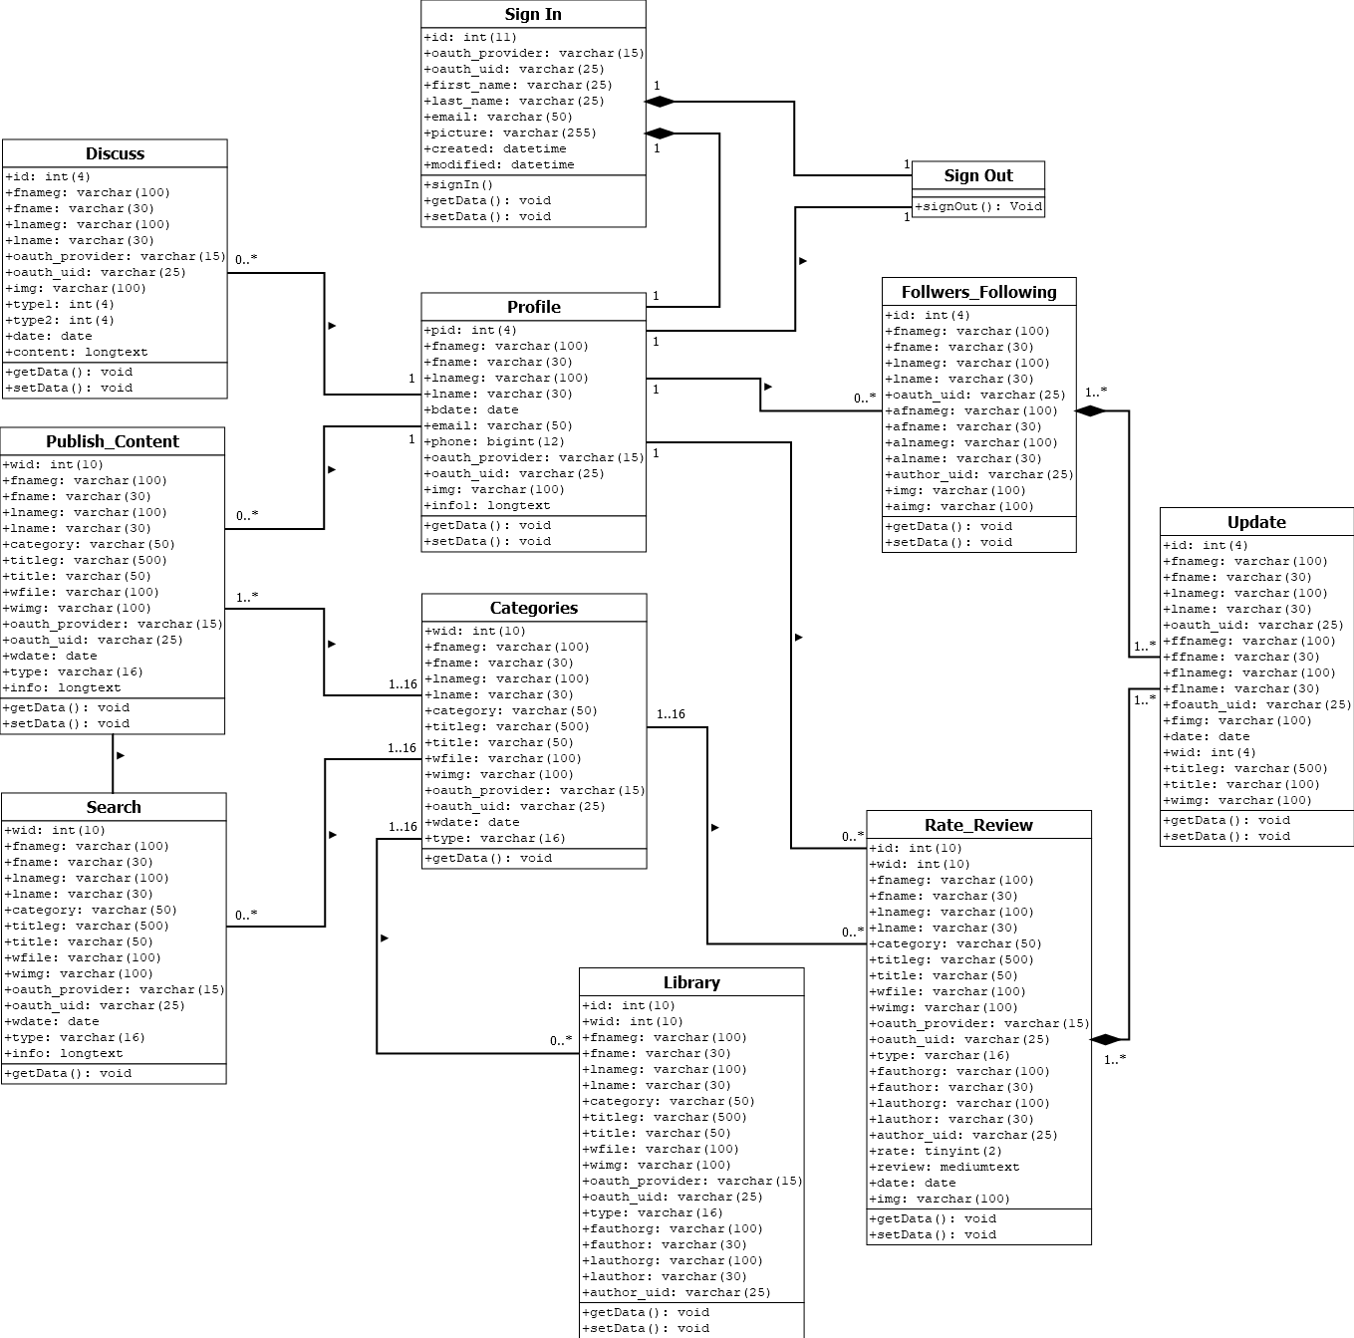

**Activity Diagram:**

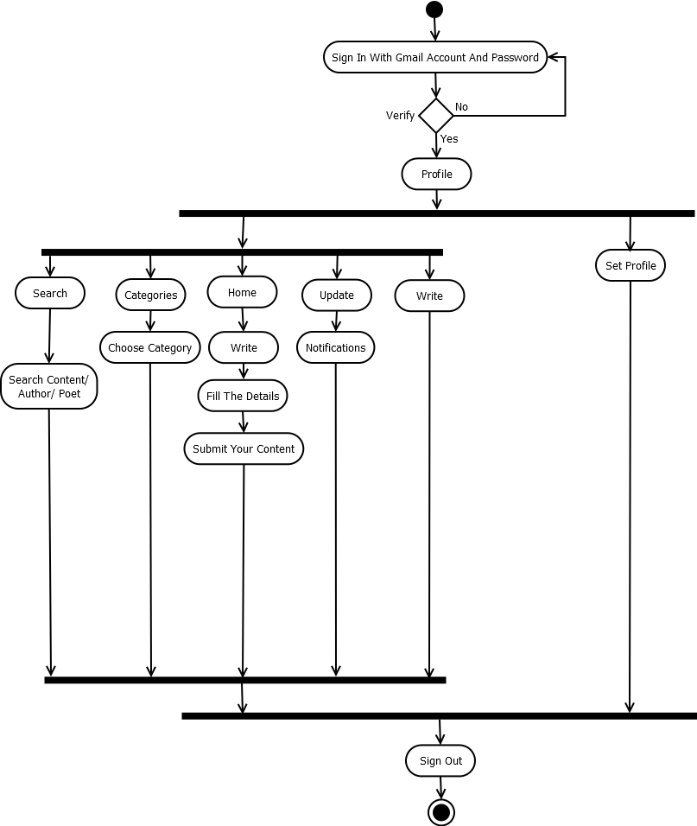

**FILE STRUCTURE WITH DESCRIPTION**

**Users Table:**

|  |  |  |  |  |  |
| --- | --- | --- | --- | --- | --- |
| **Sr. No.** | **Column Name** | **Data Type** | **Size** | **Constraint** | **Description** |
| 1. | id | int | 11 | Auto Increment | Primary Key |
| 2. | oauth_provider | varchar | 15 | NOT NULL | Google |
| 3. | oauth_uid | varchar | 25 | NOT NULL | Google ID |
| 4. | first_name | varchar | 25 | NOT NULL | First Name |
| 5. | last_name | varchar | 25 | NOT NULL | Last Name |
| 6. | email | varchar | 50 | NOT NULL | Email |
| 7. | picture | varchar | 255 | NOT NULL | Image |
| 8. | created | datetime | - | NOT NULL | Created Date |
| 9. | modified | datetime | - | NOT NULL | Created Date |

**Profile Table:**

|  |  |  |  |  |  |
| --- | --- | --- | --- | --- | --- |
| **Sr. No.** | **Column Name** | **Data Type** | **Size** | **Constraint** | **Description** |
| 1. | pid | int | 4 | Auto Increment | Primary Key |
| 2. | fnameg | varchar | 100 | NOT NULL | First Name [G] |
| 3. | fname | varchar | 30 | NOT NULL | First Name |
| 4. | lnameg | varchar | 100 | NOT NULL | Last Name [G] |
| 5. | lname | varchar | 30 | NOT NULL | Last Name |
| 6. | bdate | date | - | NOT NULL | Birthdate |
| 7. | email | varchar | 50 | NOT NULL | Email |
| 8. | phone | bigint | 12 | NOT NULL | Phone No. |
| 9. | oauth_provider | varchar | 15 | NOT NULL | Google |
| 10. | oauth_uid | varchar | 25 | NOT NULL | Google ID |
| 11. | img | varchar | 100 | NOT NULL | Image |
| 12. | info1 | longtext | - | NOT NULL | Text |

**Write_Content Table:**

|  |  |  |  |  |  |
| --- | --- | --- | --- | --- | --- |
| **Sr. No.** | **Column Name** | **Data Type** | **Size** | **Constraint** | **Description** |
| 1. | wid | int | 10 | Auto Increment | Primary Key |
| 2. | fnameg | varchar | 100 | NOT NULL | First Name [G] |
| 3. | fname | varchar | 30 | NOT NULL | First Name |
| 4. | lnameg | varchar | 100 | NOT NULL | Last Name [G] |
| 5. | lname | varchar | 30 | NOT NULL | Last Name |
| 6. | category | varchar | 50 | NOT NULL | Category |
| 7. | titleg | varchar | 500 | NOT NULL | Title [G] |
| 8. | title | varchar | 50 | NOT NULL | Title |
| 9. | wfile | varchar | 100 | NOT NULL | File Name |
| 10. | wimg | varchar | 100 | NOT NULL | File Image |
| 11. | oauth_provider | varchar | 15 | NOT NULL | Google |
| 12. | oauth_uid | varchar | 25 | NOT NULL | Google ID |
| 13. | wdate | date | - | NOT NULL | Date |
| 14. | type | varchar | 16 | NOT NULL | Type |
| 15. | info | longtext | - | NOT NULL | Text |

**RateReview Table:**

|  |  |  |  |  |  |
| --- | --- | --- | --- | --- | --- |
| **Sr. No.** | **Column Name** | **Data Type** | **Size** | **Constraint** | **Description** |
| 1. | id | int | 10 | Auto Increment | Primary Key |
| 2. | wid | int | 10 | NOT NULL | ID |
| 3. | fnameg | varchar | 100 | NOT NULL | First Name [G] |
| 4. | fname | varchar | 30 | NOT NULL | First Name |
| 5. | lnameg | varchar | 100 | NOT NULL | Last Name [G] |
| 6. | lname | varchar | 30 | NOT NULL | Last Name |
| 7. | category | varchar | 50 | NOT NULL | Category |
| 8. | titleg | varchar | 500 | NOT NULL | Title [G] |
| 9. | title | varchar | 50 | NOT NULL | Title |
| 10. | wfile | varchar | 100 | NOT NULL | File Name |
| 11. | wimg | varchar | 100 | NOT NULL | File Image |
| 12. | oauth_provider | varchar | 15 | NOT NULL | Google |
| 13. | oauth_uid | varchar | 25 | NOT NULL | Google ID |
| 14. | type | varchar | 16 | NOT NULL | Type |
| 15. | fauthorg | varchar | 100 | NOT NULL | Author First Name [G] |
| 16. | fauthor | varchar | 30 | NOT NULL | Author First Name |
| 17. | lauthorg | varchar | 100 | NOT NULL | Author Last Name [G] |
| 18. | lauthor | varchar | 30 | NOT NULL | Author Last Name |
| 19. | author_uid | varchar | 25 | NOT NULL | Author Google ID |
| 20. | rate | tinyint | 2 | NOT NULL | Rate |
| 21. | review | mediumtext | - | NOT NULL | Review |
| 22. | date | date | - | NOT NULL | Date |
| 23. | img | varchar | 100 | NOT NULL | Image |

**Library Table:**

|  |  |  |  |  |  |
| --- | --- | --- | --- | --- | --- |
| **Sr. No.** | **Column Name** | **Data Type** | **Size** | **Constraint** | **Description** |
| 1. | id | int(10) | 10 | Auto Increment | Primary Key |
| 2. | wid | int(10) | 10 | NOT NULL | ID |
| 3. | fnameg | varchar(100) | 100 | NOT NULL | First Name [G] |
| 4. | fname | varchar(30) | 30 | NOT NULL | First Name |
| 5. | lnameg | varchar(100) | 100 | NOT NULL | Last Name [G] |
| 6. | lname | varchar(30) | 30 | NOT NULL | Last Name |
| 7. | category | varchar(50) | 50 | NOT NULL | Category |
| 8. | titleg | varchar(500) | 500 | NOT NULL | Title [G] |
| 9. | title | varchar(50) | 50 | NOT NULL | Title |
| 10. | wfile | varchar(100) | 100 | NOT NULL | File Name |
| 11. | wimg | varchar(100) | 100 | NOT NULL | File Image |
| 12. | oauth_provider | varchar(15) | 15 | NOT NULL | Google |
| 13. | oauth_uid | varchar(25) | 25 | NOT NULL | Google ID |
| 14. | type | varchar(16) | 16 | NOT NULL | Type |
| 15. | fauthorg | varchar(100) | 100 | NOT NULL | Author First Name [G] |
| 16. | fauthor | varchar(30) | 30 | NOT NULL | Author First Name |
| 17. | lauthorg | varchar(100) | 100 | NOT NULL | Author Last Name [G] |
| 18. | lauthor | varchar(30) | 30 | NOT NULL | Author Last Name |
| 19. | author_uid | varchar(25) | 25 | NOT NULL | Author Google ID |

**FollowersFollowing Table:**

|  |  |  |  |  |  |
| --- | --- | --- | --- | --- | --- |
| **Sr. No.** | **Column Name** | **Data Type** | **Size** | **Constraint** | **Description** |
| 1 | id | int | 4 | Auto Increment | Primary Key |
| 2 | fnameg | varchar | 100 | NOT NULL | First Name [G] |
| 3 | fname | varchar | 30 | NOT NULL | First Name |
| 4 | lnameg | varchar | 100 | NOT NULL | Last Name [G] |
| 5 | lname | varchar | 30 | NOT NULL | Last Name |
| 6 | oauth_uid | varchar | 25 | NOT NULL | Google ID |
| 7 | afnameg | varchar | 100 | NOT NULL | Follower First Name [G] |
| 8 | afname | varchar | 30 | NOT NULL | Follower First Name |
| 9 | alnameg | varchar | 100 | NOT NULL | Follower Last Name [G] |
| 10 | alname | varchar | 30 | NOT NULL | Follower Last Name |
| 11 | author_uid | varchar | 25 | NOT NULL | Follower Google ID |
| 12 | img | varchar | 100 | NOT NULL | Image |
| 13 | aimg | varchar | 100 | NOT NULL | Follower Image |

**Update1 Table:**

|  |  |  |  |  |  |
| --- | --- | --- | --- | --- | --- |
| **Sr. No.** | **Column Name** | **Data Type** | **Size** | **Constraint** | **Description** |
| 1. | id | int | 4 | Auto Increment | Primary Key |
| 2. | fnameg | varchar | 100 | NOT NULL | First Name [G] |
| 3. | fname | varchar | 30 | NOT NULL | First Name |
| 4. | lnameg | varchar | 100 | NOT NULL | Last Name [G] |
| 5. | lname | varchar | 30 | NOT NULL | Last Name |
| 6. | oauth_uid | varchar | 25 | NOT NULL | Google ID |
| 7. | ffnameg | varchar | 100 | NOT NULL | Follower First Name [G] |
| 8. | ffname | varchar | 30 | NOT NULL | Follower First Name |
| 9. | flnameg | varchar | 100 | NOT NULL | Follower Last Name [G] |
| 10. | flname | varchar | 30 | NOT NULL | Follower Last Name |
| 11. | foauth_uid | varchar | 25 | NOT NULL | Follower Google ID |
| 12. | fimg | varchar | 100 | NOT NULL | Follower Image |
| 13. | date | date | - | NOT NULL | Date |
| 14. | wid | int | 4 | NOT NULL | ID |
| 15. | titleg | varchar | 500 | NOT NULL | Title [G] |
| 16. | title | varchar | 100 | NOT NULL | Title |
| 17. | wimg | varchar | 100 | NOT NULL | File Image |

**Discuss Table:**

|  |  |  |  |  |  |
| --- | --- | --- | --- | --- | --- |
| **Sr. No.** | **Column Name** | **Data Type** | **Size** | **Constraint** | **Description** |
| 1. | id | int | 4 | Auto Increment | Primary Key |
| 2. | fnameg | varchar | 100 | NOT NULL | First Name [G] |
| 3. | fname | varchar | 30 | NOT NULL | First Name |
| 4. | lnameg | varchar | 100 | NOT NULL | Last Name [G] |
| 5. | lname | varchar | 30 | NOT NULL | Last Name |
| 6. | oauth_provider | varchar | 15 | NOT NULL | Google |
| 7. | oauth_uid | varchar | 25 | NOT NULL | Google ID |
| 8. | img | varchar | 100 | NOT NULL | Image |
| 9. | type1 | int | 4 | NOT NULL | Type - 1 |
| 10. | type2 | int | 4 | NOT NULL | Type - 2 |
| 11. | date | date | - | NOT NULL | Date |
| 12. | content | longtext | - | NOT NULL | Content |